We will have 4 screens to meet this requirement.

1. Supplier Master data entry & view the list of suppliers
2. Goods Entry form and view the Goods received
3. Bulk upload of supplier data into table
4. Print label as given as image

The screen layout may be in the following form,

**Add New Supplier**:

The supplier master screen may look like below. We may need to come up with upload feature as well for the supplier master records. During the upload feature we need to validate the data as per the data format expected in the attached python script and sample supplier list.

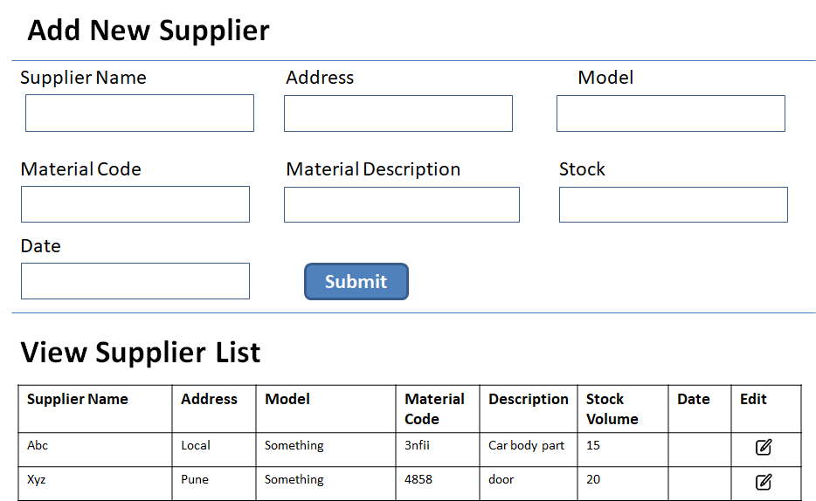

In the form Supplier name filed may be used as supplier search screen, on selection of the pick list, the supplier name can be populated in the name field. Rest of the fields may be entered by the admin person. In case the existing record should be updated, then click the edit icon, the respective data may be populated in the form and user may update the records.

**Goods Entry Form:**

This form is being used to capture material received at the factory site.

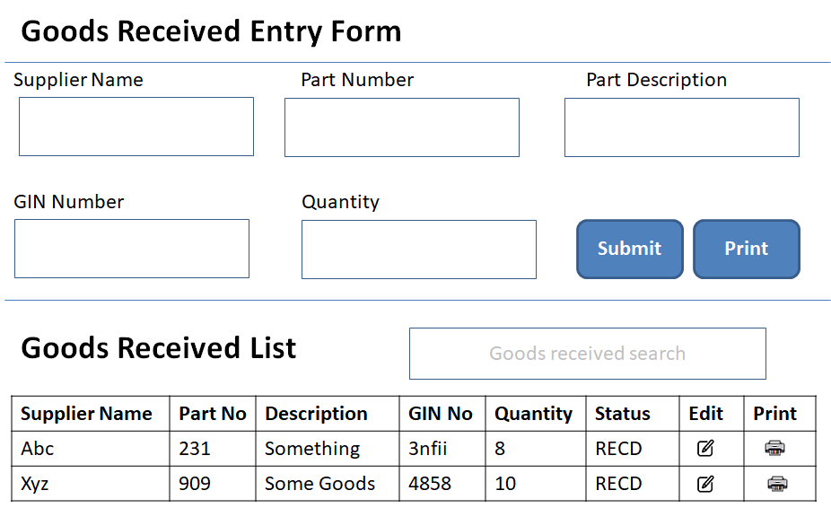

The supplier name field is a search field, similar to google search field. on selection of the supplier, the name of the supplier can be populated and the supplier id supposed to be kept in the backend to insert the data into goods_received_master table. On submit of the form, data must be saved into database. On click of the print button, the reporting popup window should show the data for printing.

In below given table, on click of the edit icon, the respective data gets populated in the form. This will help us to edit the data entered are wrong.

Goods Received search box help us to locate the correct goods by searching either by supplier name or material description. We may need to consider material status as well, as the requirement is not clear, we can live with as of now, later the criteria can be applied.

On click of the print icon, the below shown window should come as a popup, supposed to be designed with the help of reporting tool (Crystal, jasper, etc). These reporting tools will help us to set the exact pointer to the printer for every line of letter.